Annotation Guidelines
- Mark only thoracic changes that would warrant bringing to the attention of an ICU clinician. Any changes related to medical devices should be excluded. Only the region containing the change should be included.
For example:
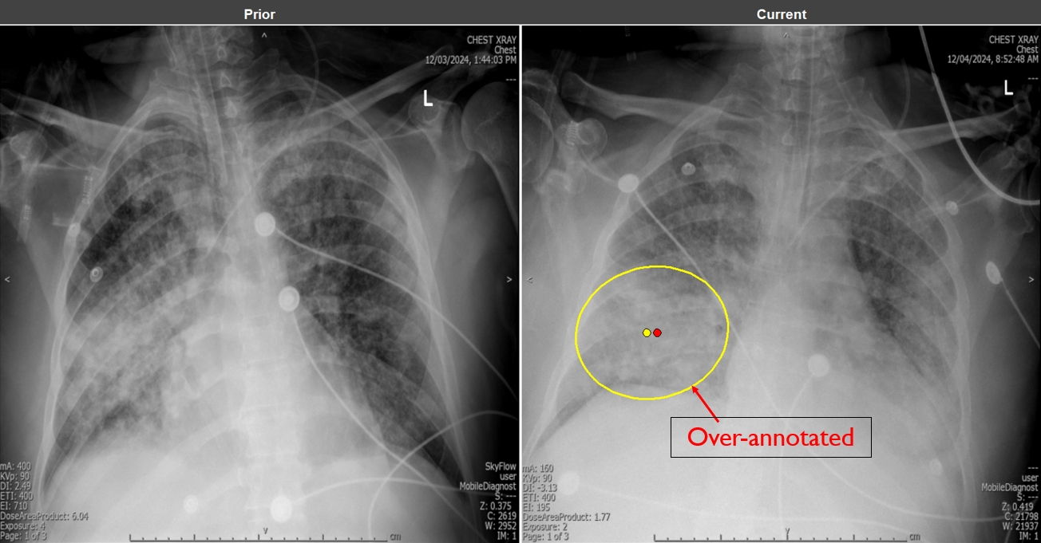
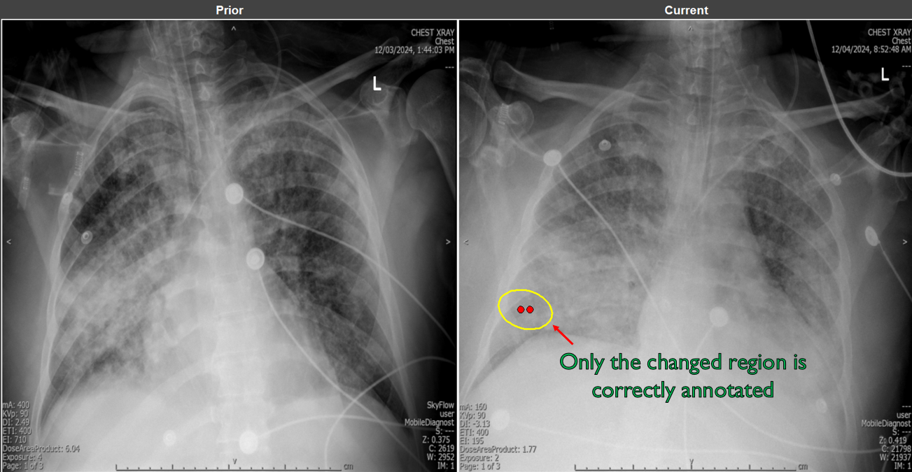
- Visual differences confidently attributable to extrinsic technical factors, such as patient rotation or posture, or acquisition parameters, should be ignored.
- Annotations and entity changes should be mapped one-to-one. Avoid using a single ellipse to cover multiple distinct changes, and conversely, avoid using multiple ellipses for a single entity change, unless it is not spatially continuous.
- An entity that is present in both the prior and the current with no meaningful change should not be annotated at all.
For example:
